MARKETPLACE MAPPING

# **Customer**

1. 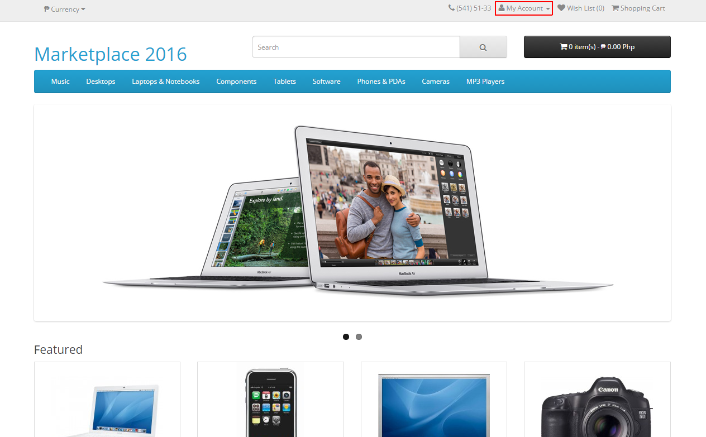**Registration**

Fig. 1.0. From the home page, click “My Account”

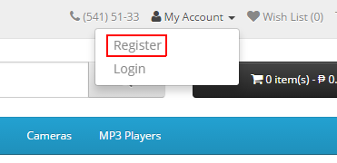

Fig. 1.2. Click “Register”

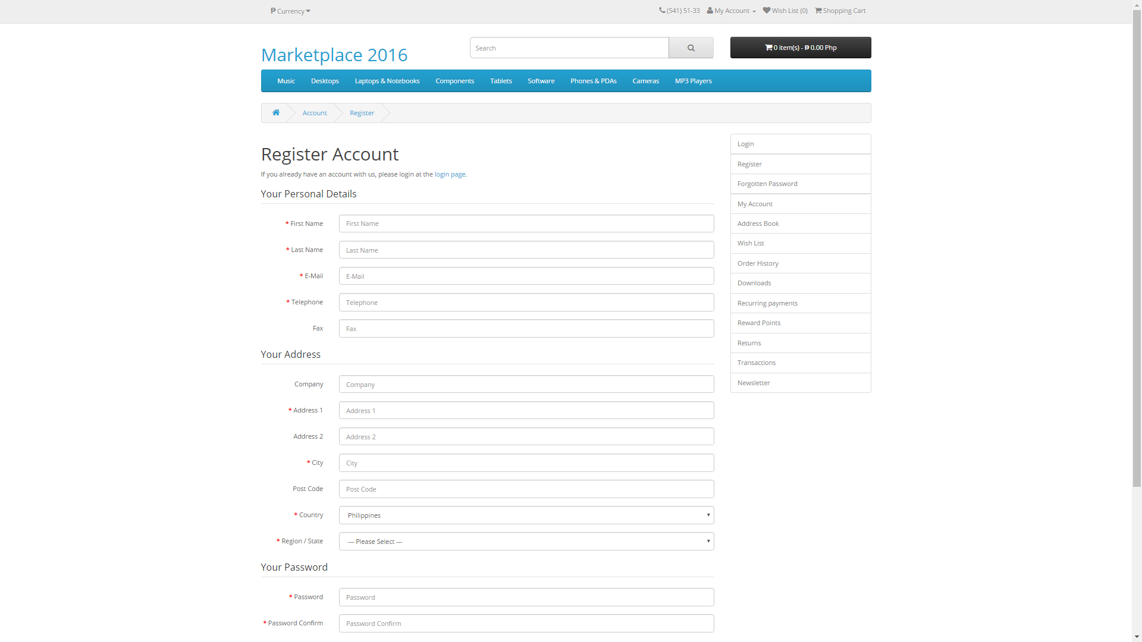

Fig. 1.3. Fill all necessary details in the registration form

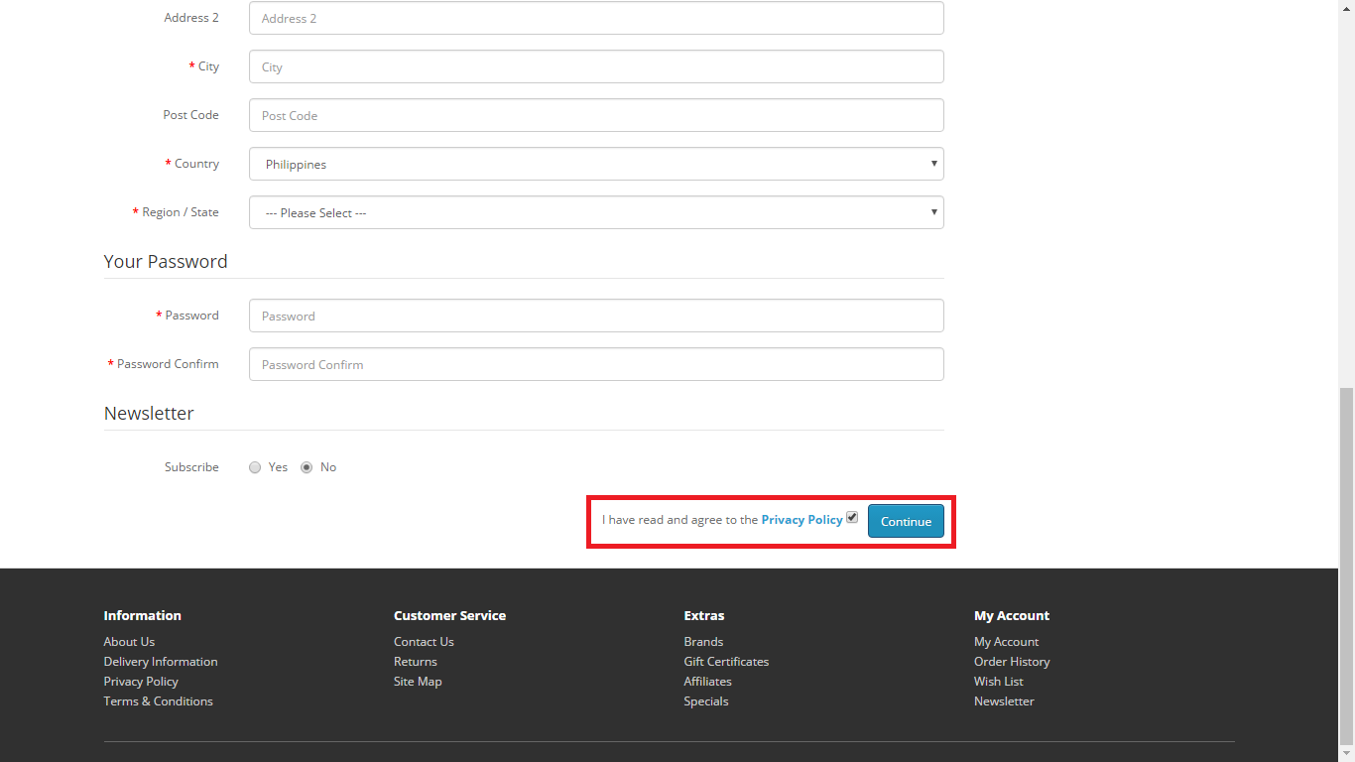

Figure 1.4. Check the box indicating you have read the Privacy Policy. After that, click “Continue” and you are officially a customer of Marketplace

1. **Browse Products**

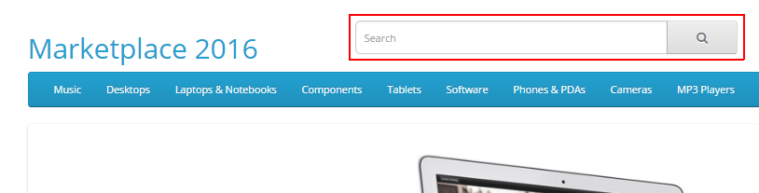

Fig. 2.0. To search for product, just simply type the name in the search bar

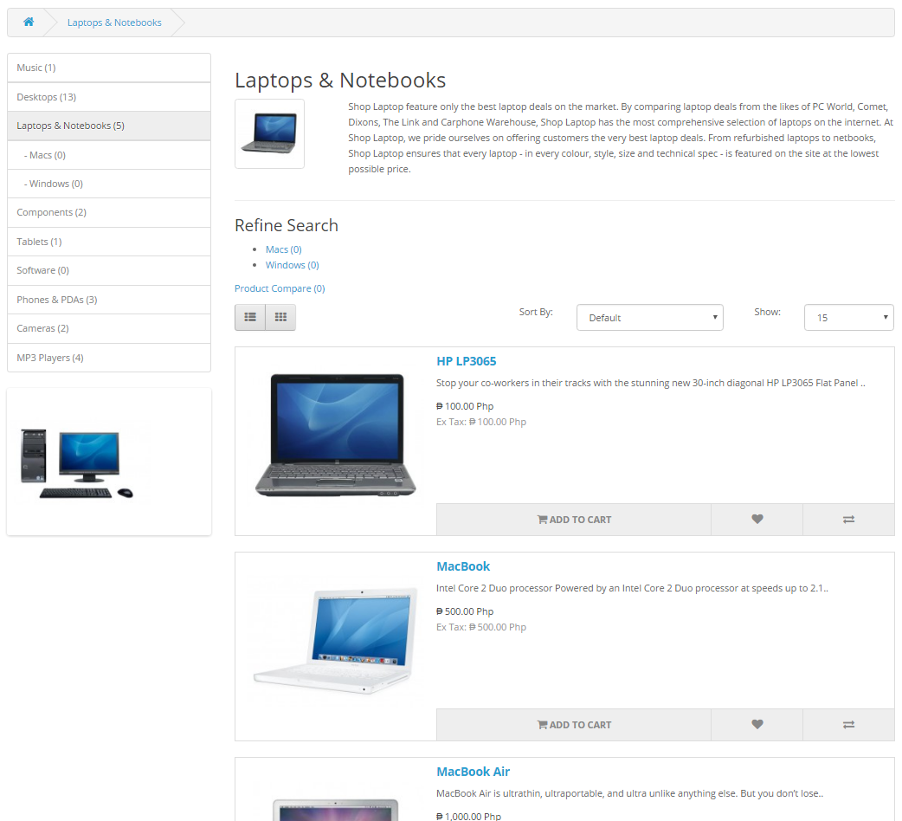

Fig. 2.1. Just simply click the categories you want to browse products

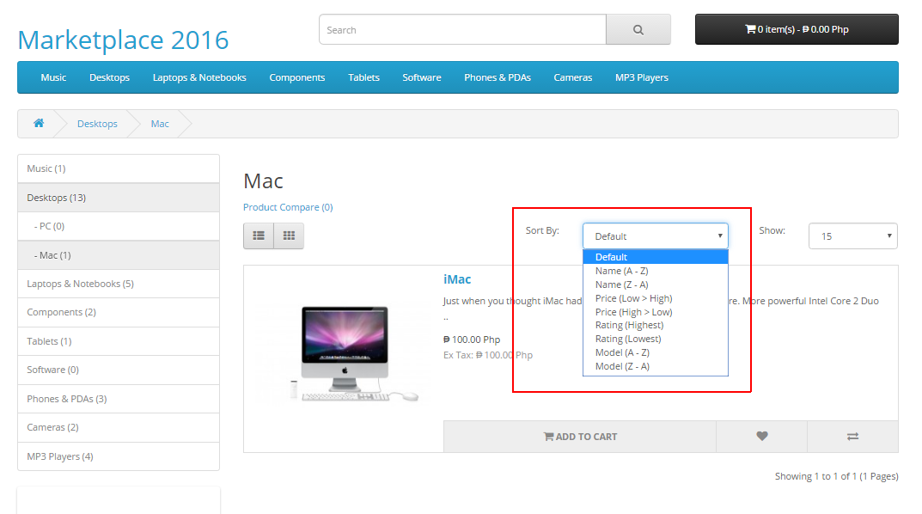

Fig. 2.2. Sorting Feature

1. **Product Page**

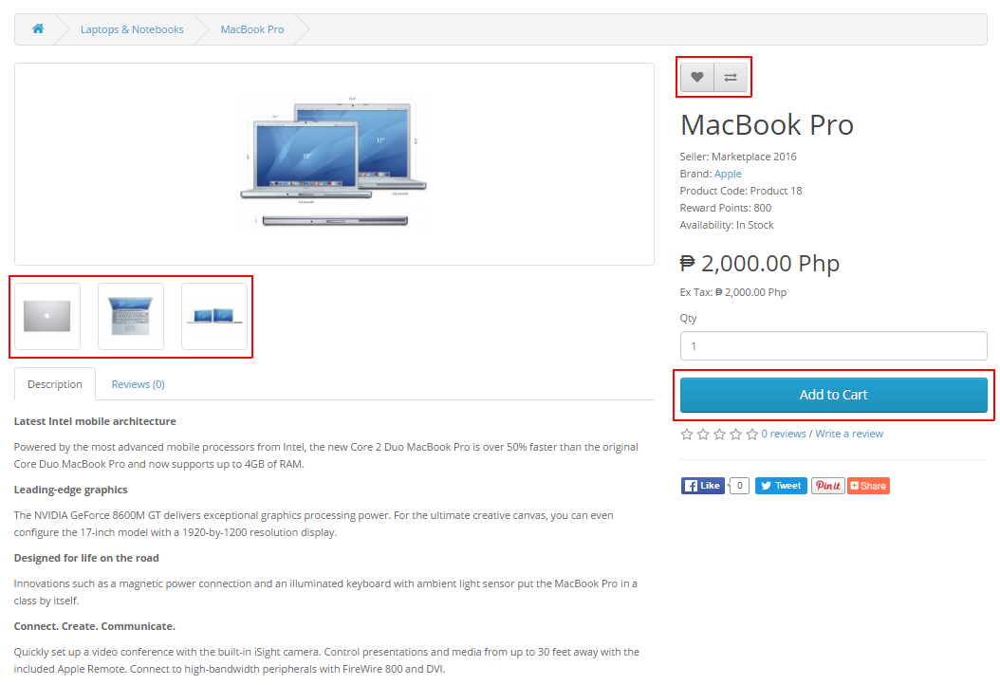

Fig. 3.0. From the left: (a) View other Images, (b) Click the heard to Add to Wish list and click the arrow to compare it to other product, (c) Click It to add the product to your cart

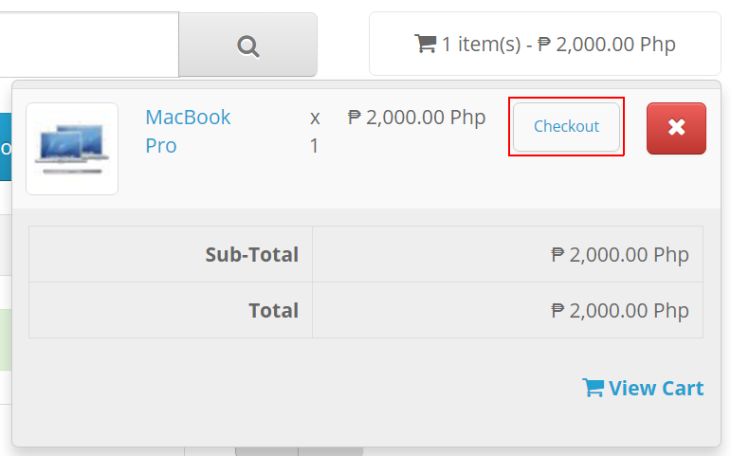

Fig. 3.1. After adding the product to cart at Figure 3.0, you can immediately checkout the product by simply clicking the “Checkout”

1. **Cart**

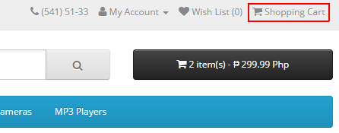

Fig. 4.0. To view your shopping cart, simply click “Shopping Cart” at the upper right corner

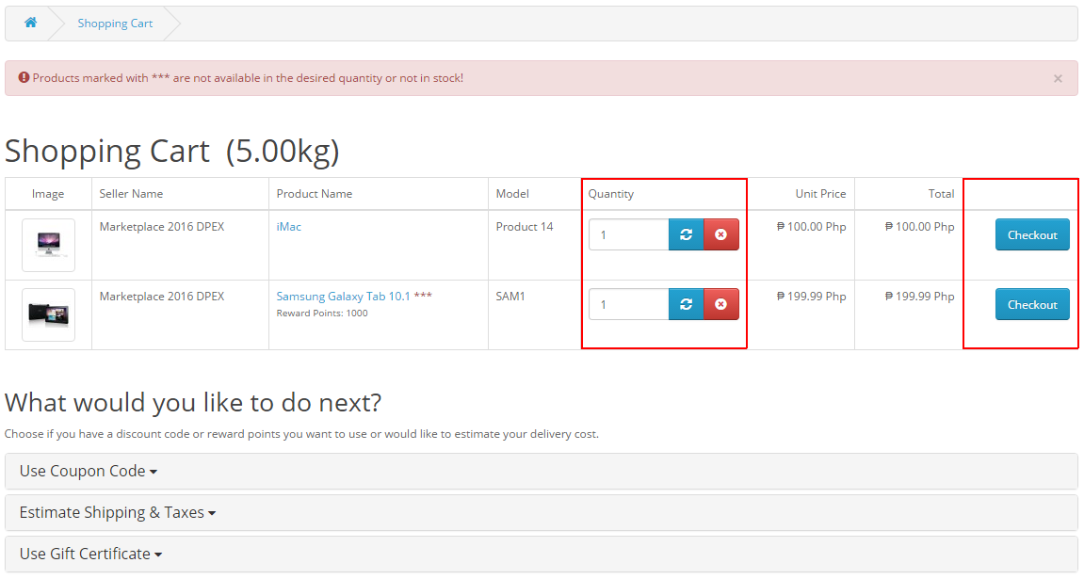

Fig. 5.1. From your shopping cart, you can: (a) change the quantity of the specific product, just write the quantity and click the button next to it and click the red button to delete it, and (b) Checkout

1. **Checkout**

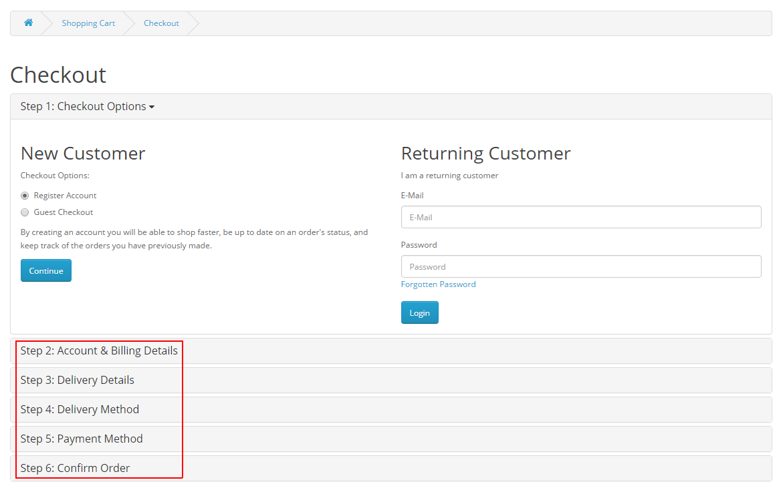

Fig. 5.0. After clicking the Checkout button, fill all necessary details step by step

1. **Orders**

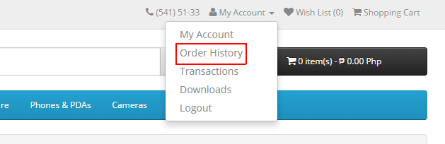

Fig. 6.0. To view order history, click “Order History” under “My Account”

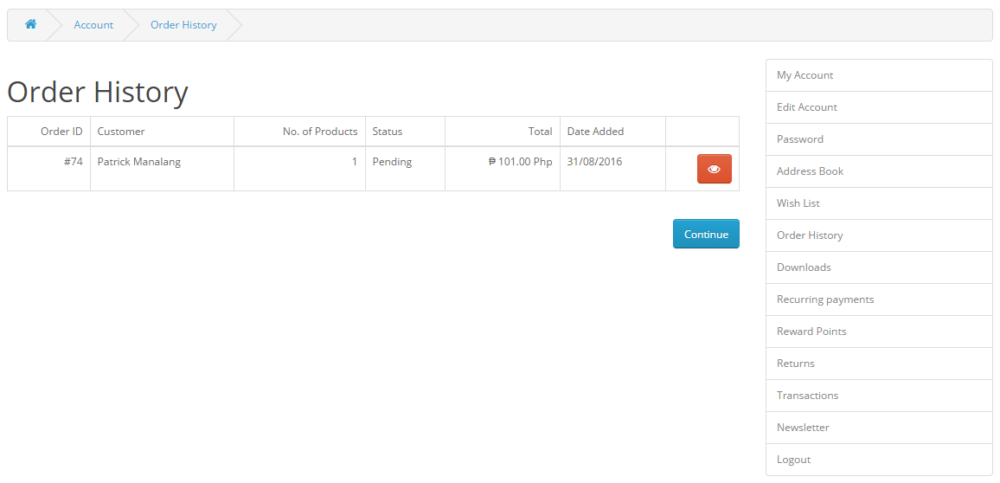

Fig. 6.1. You should be able to see the list, if you view click the red button

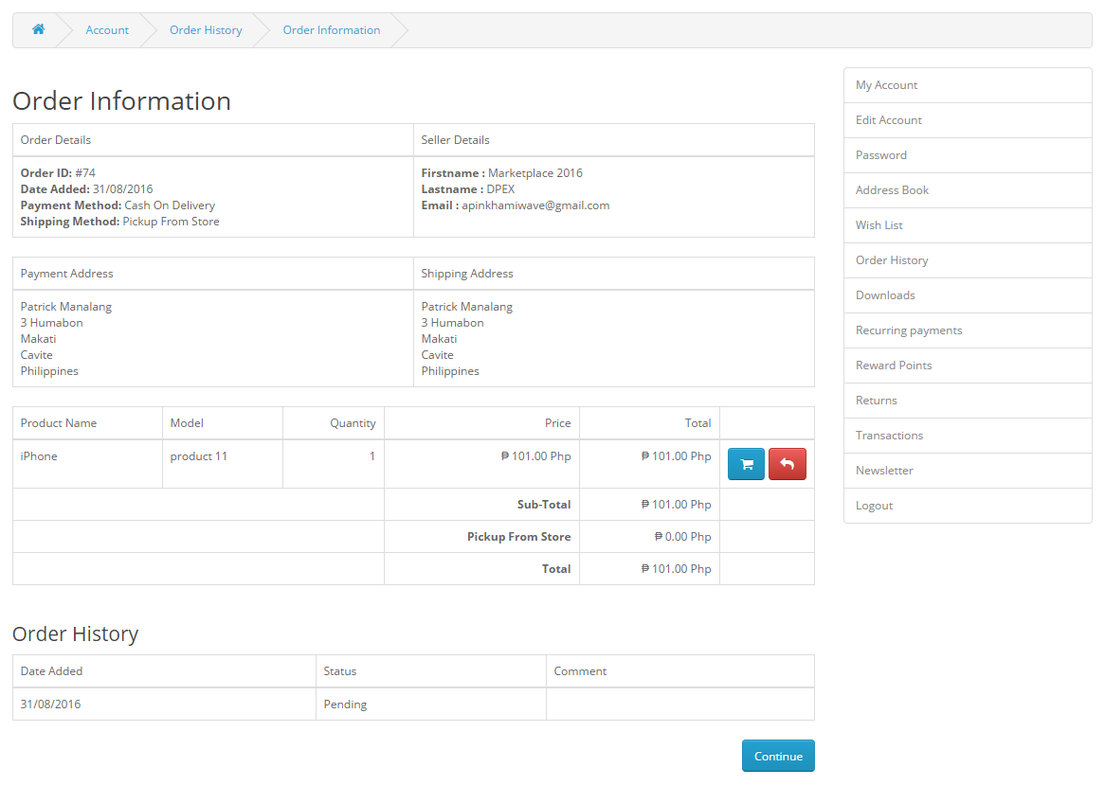

Fig. 6.2. Order Information

1. **Wish list**

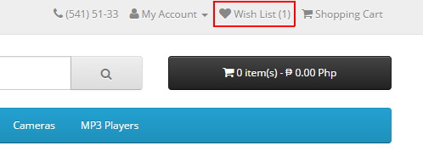

Fig. 7.0. To view your wish list, click “Wish List”

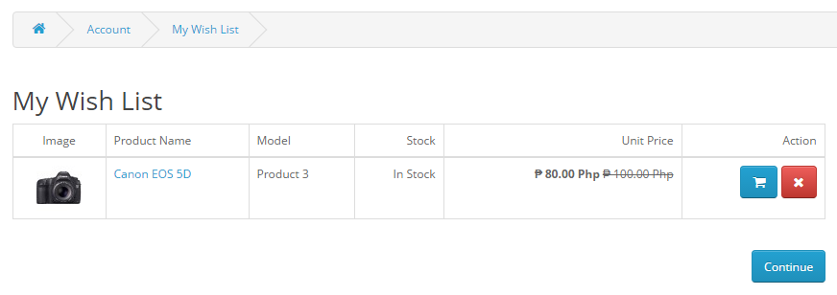

Fig. 7.1. You can: (a) Add to product to Cart by clicking the cart button, and (b) click the x button to remove product

# MERCHANT

1. 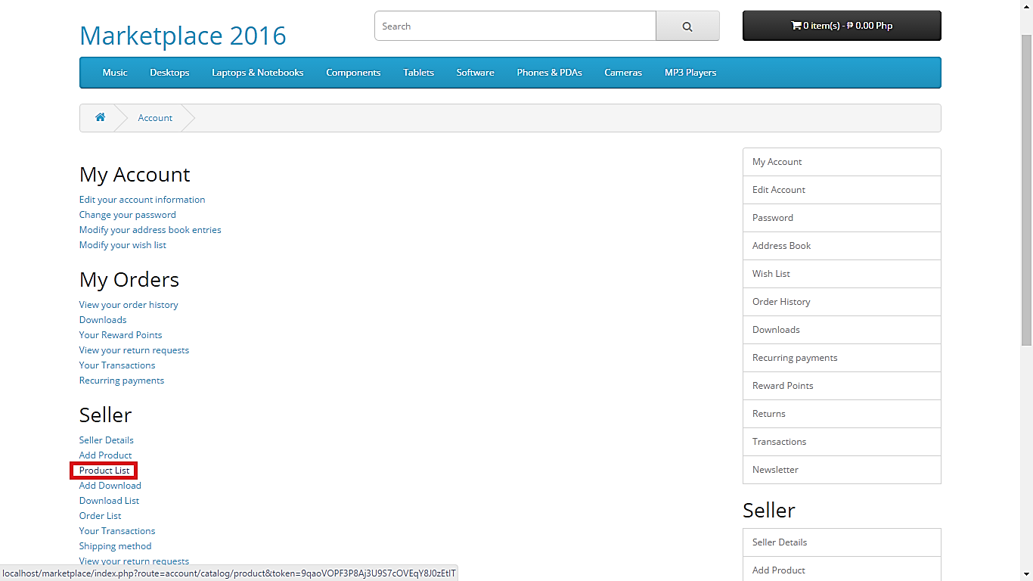**Manage Products**

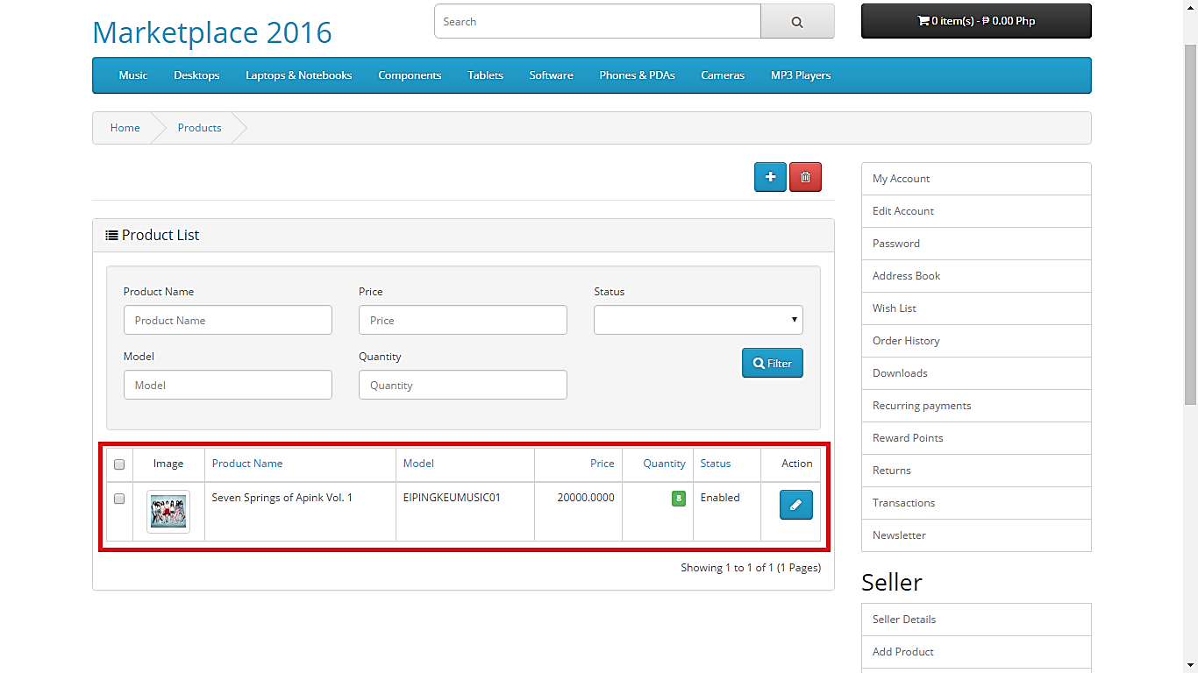Fig. 1.0. After logging in, click “Product List” to view all products

Fig. 1.2. You should be able to view all the products. In this example, we’ve been able to view one product

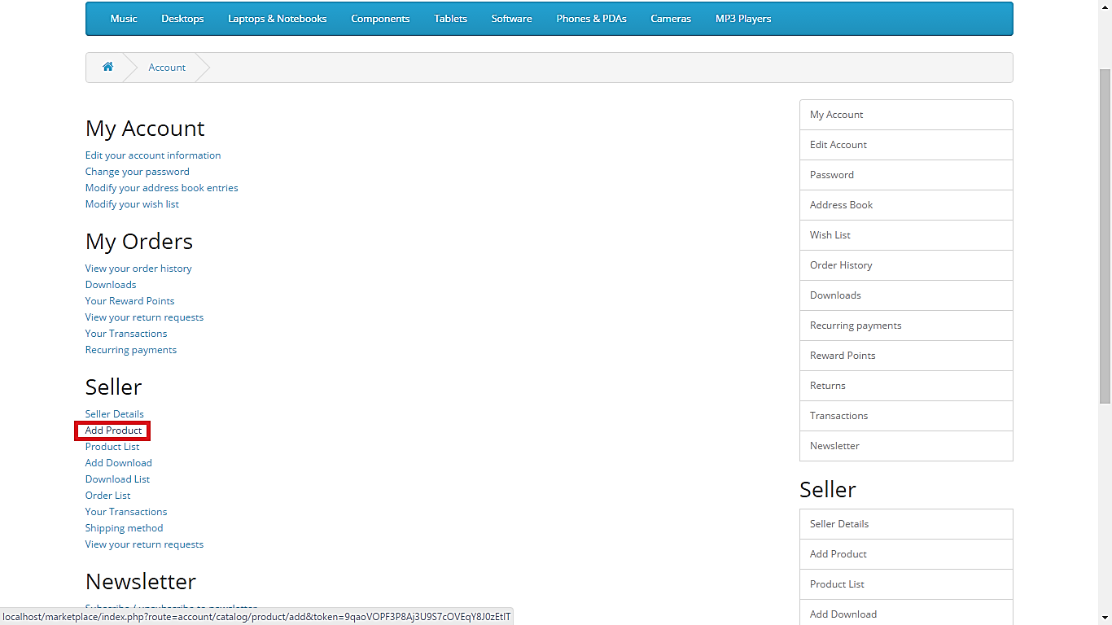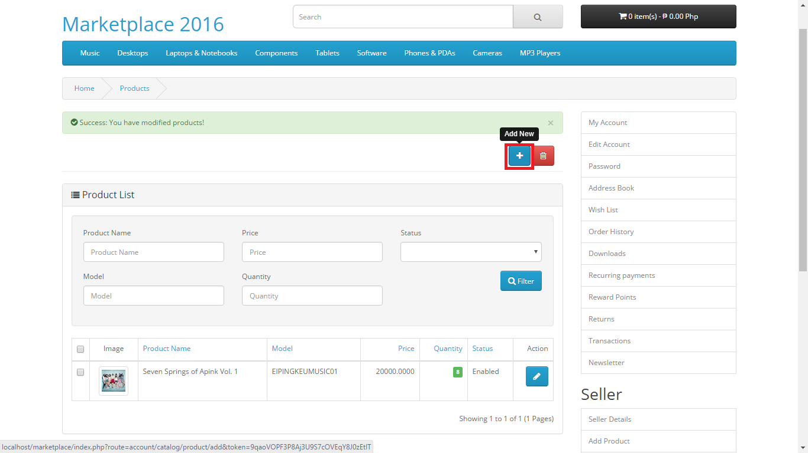There are two ways to add a product. First, adding a product directly from the product list. Lastly, adding a product from your account.

Fig. 2.1. Add Product from the product list by clicking “Add New”

Fig. 2.0. Click “Add Product”

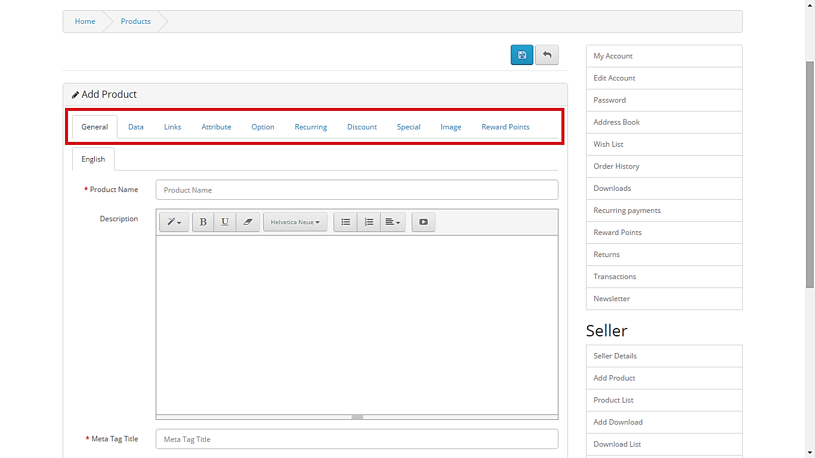from your account

Fig. 2.2. Fill all necessary details about the product

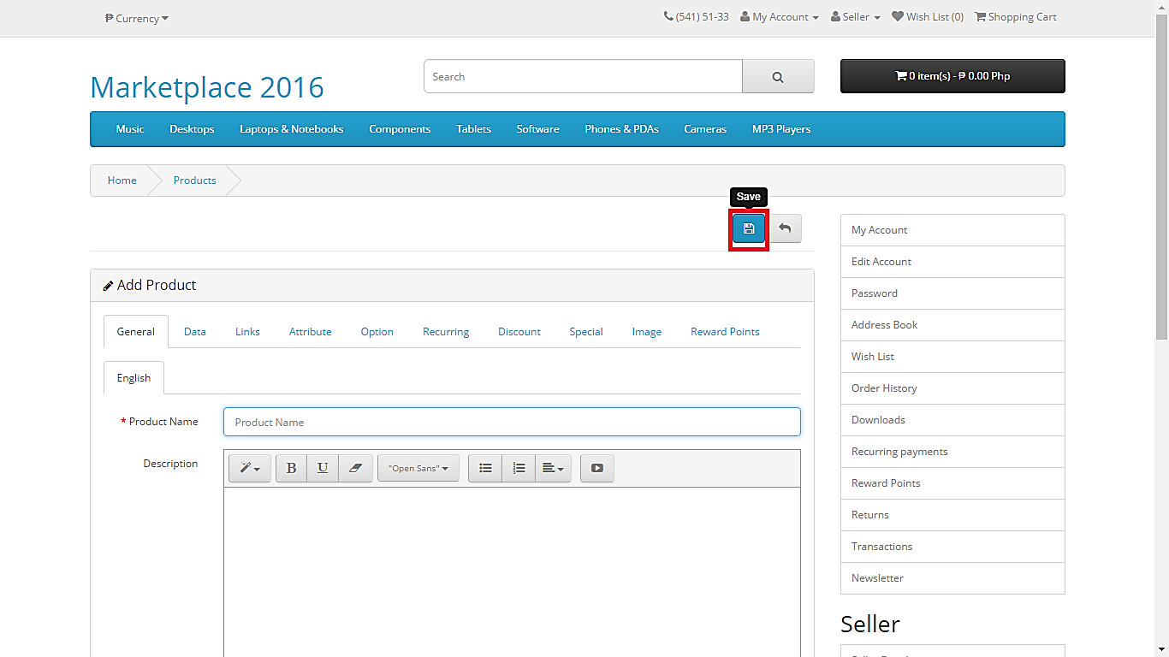Fig. 2.3. After filling all details, click “Save” to officially add the product to your product list

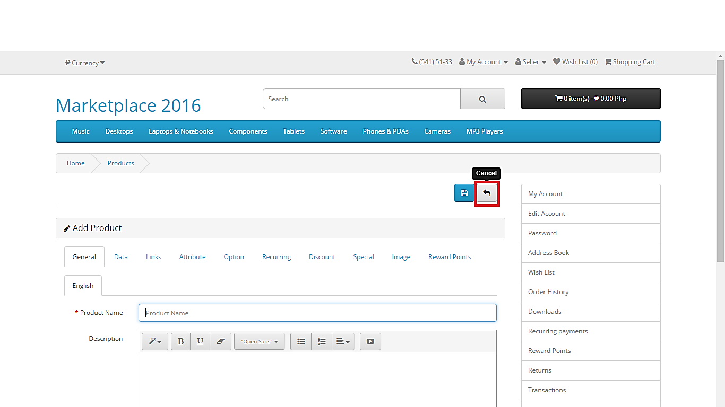

Fig. 2.4. Click “Cancel” to cancel creating new product

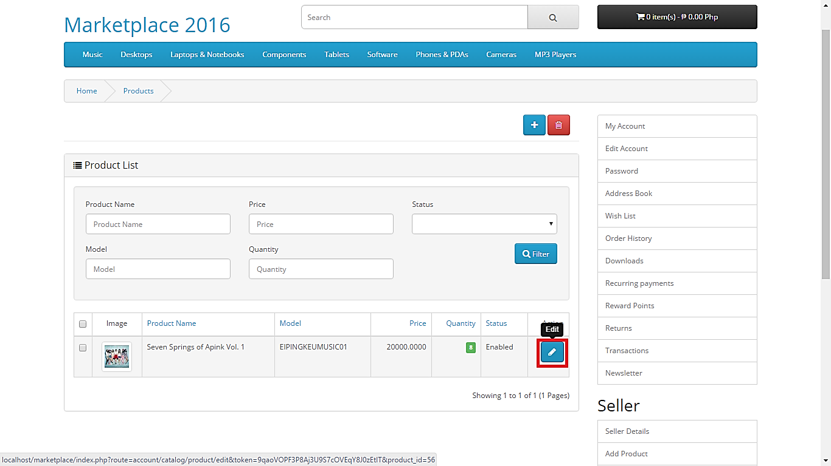

Fig. 3.0. To update the product, click “Edit” to the product from the product list

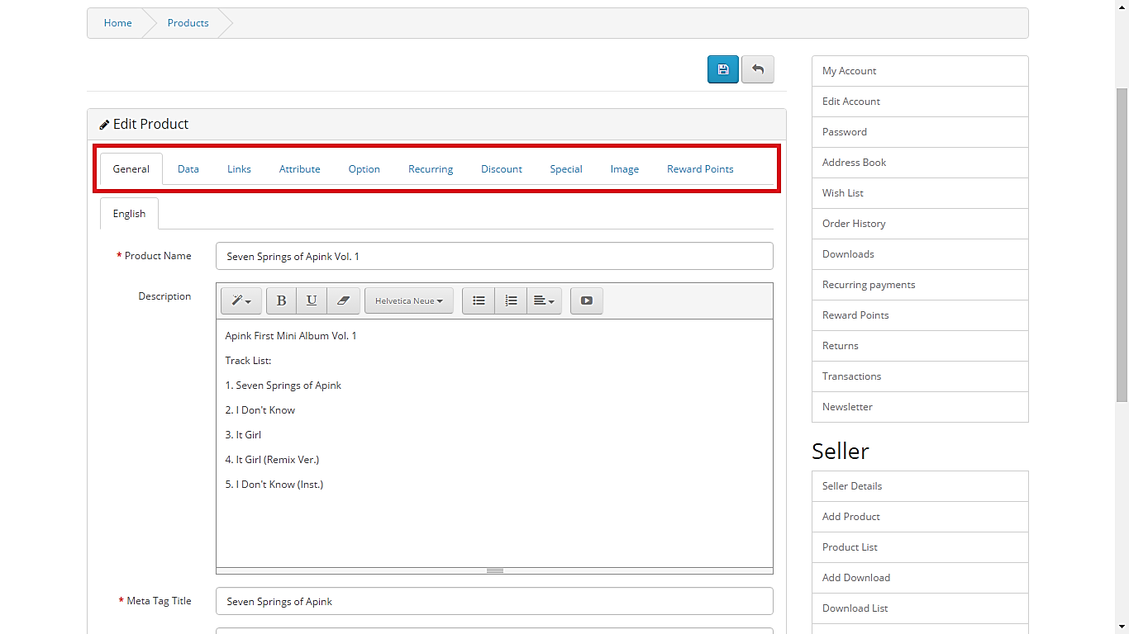

Fig. 3.1. Make necessary changes to the detail of the product

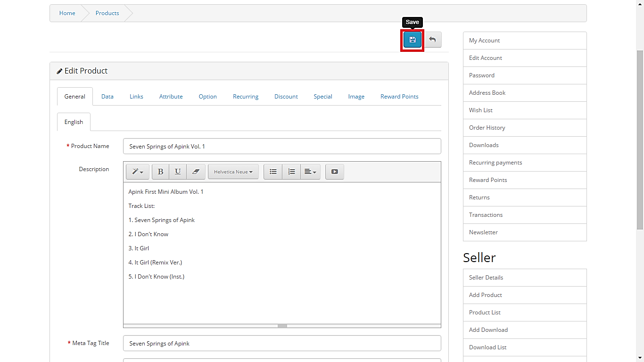

Fig. 3.2. Click “Save” after making changes

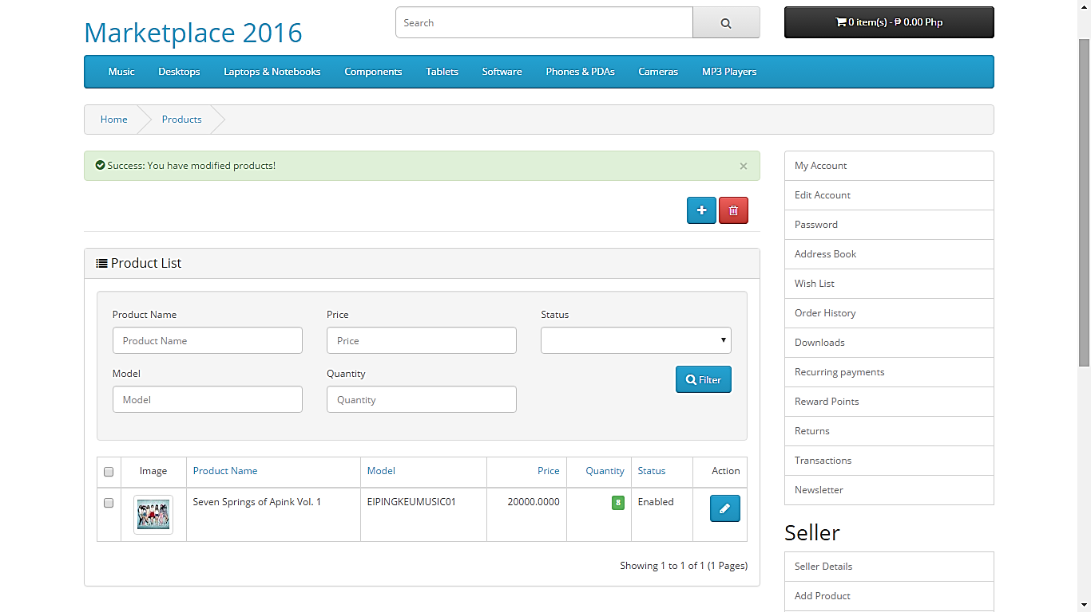

Fig. 3.3. After saving, a message will display that you have updated the product

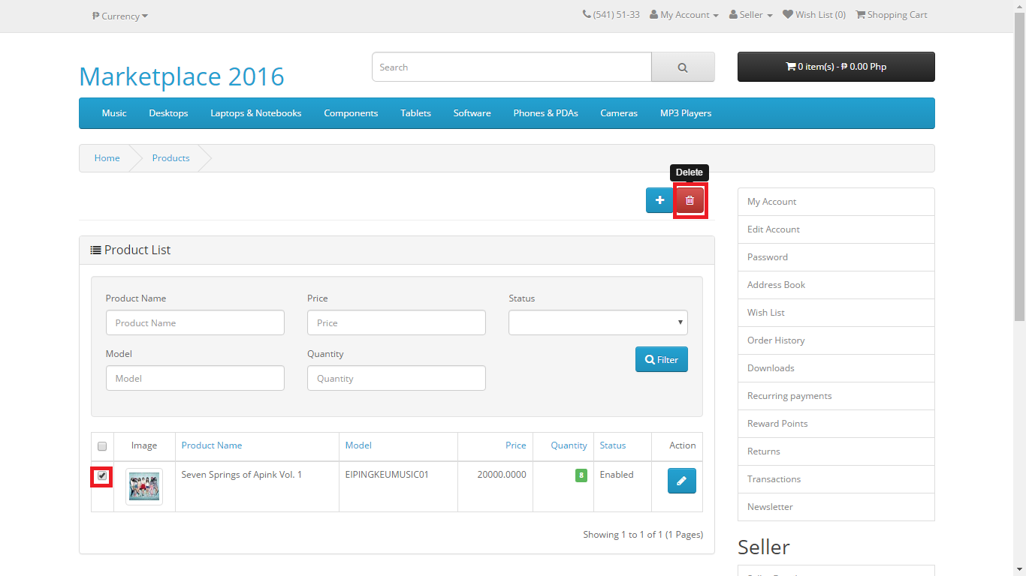

Fig. 4.0. To delete a product, check the product you want to remove and click “Delete” button

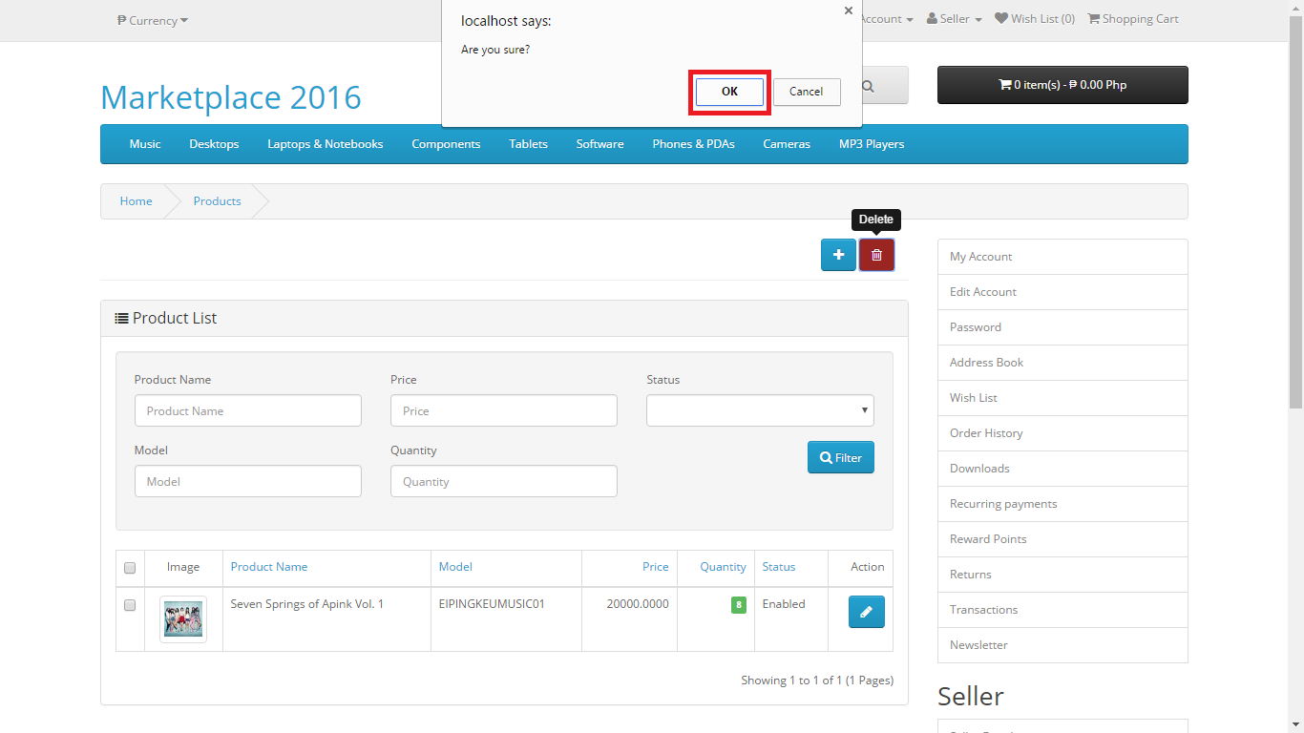

Fig. 4.1. A dialog will pop up, click “Ok” if you are sure to delete the product

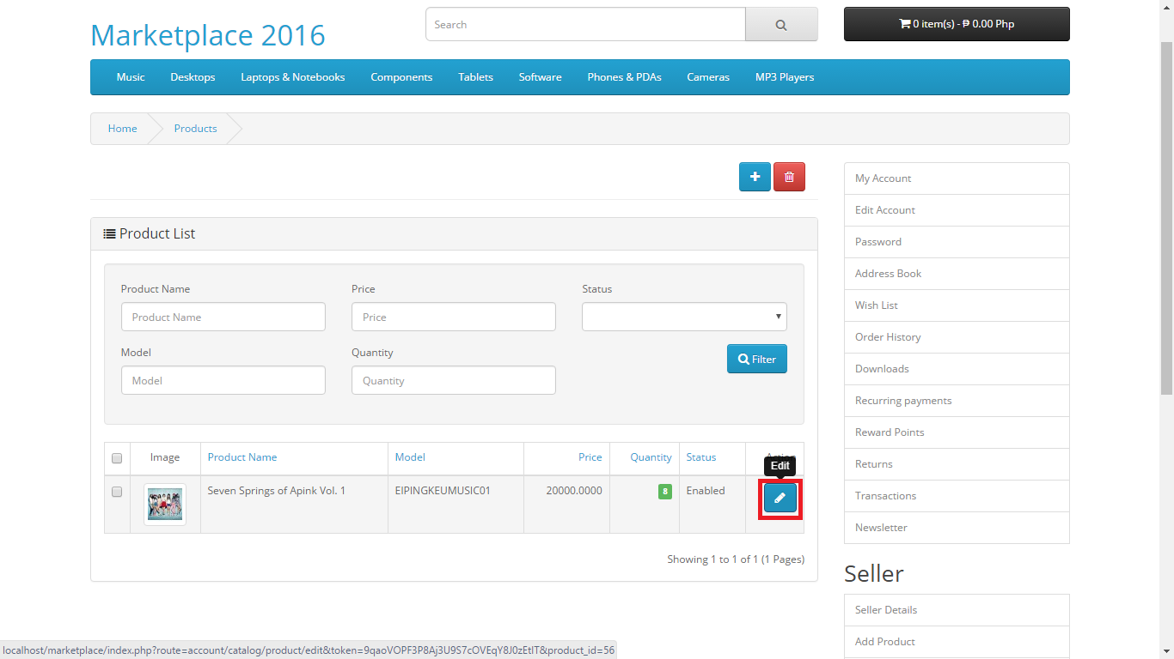

Fig. 5.0. From the product list, click “Edit” to the specific product

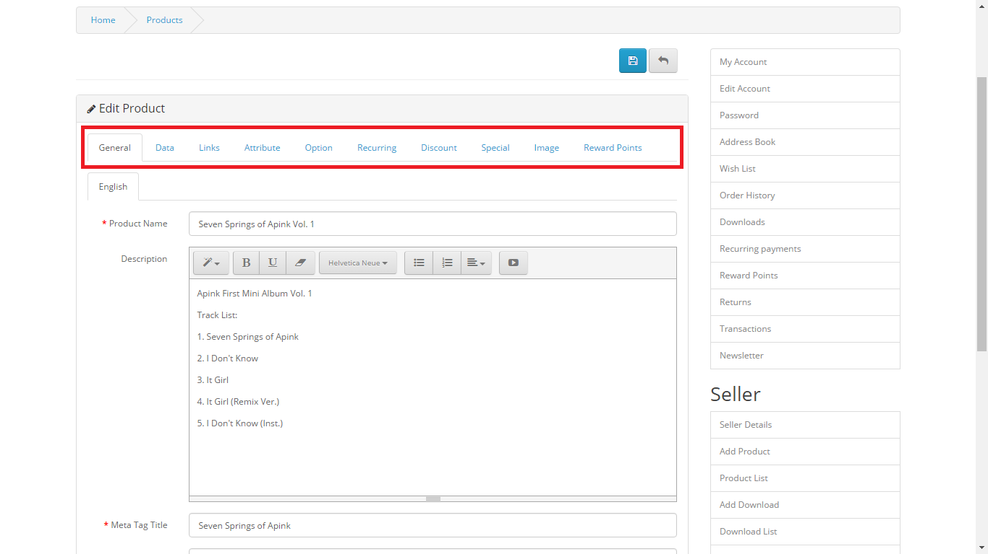

Fig. 5.1. Make necessary changes to the details you want to edit

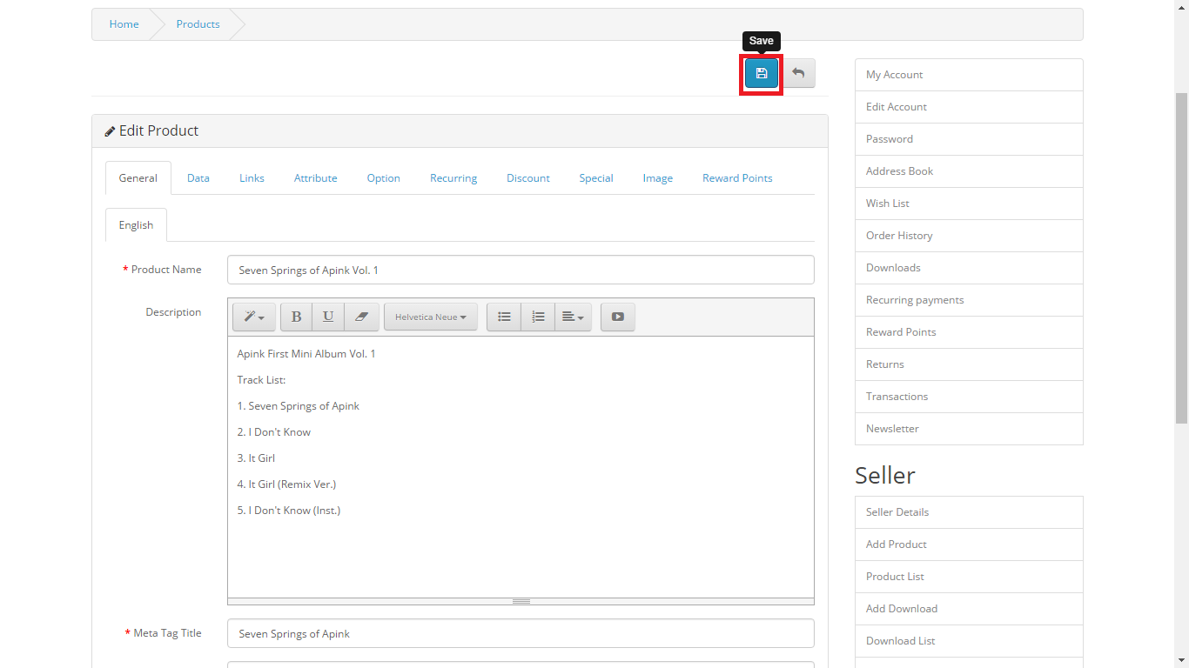

Fig. 5.2. Click “Save” afterwards

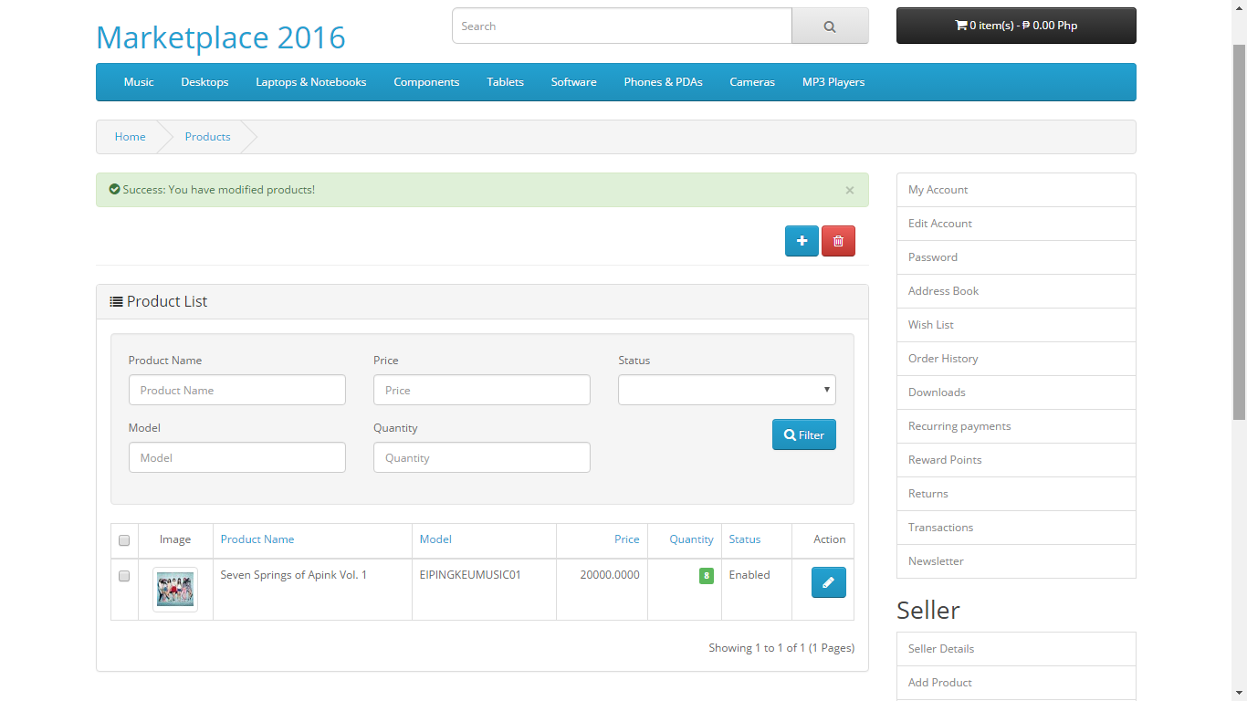

Fig. 5.3. A message will display saying you have successfully updated the product

1. 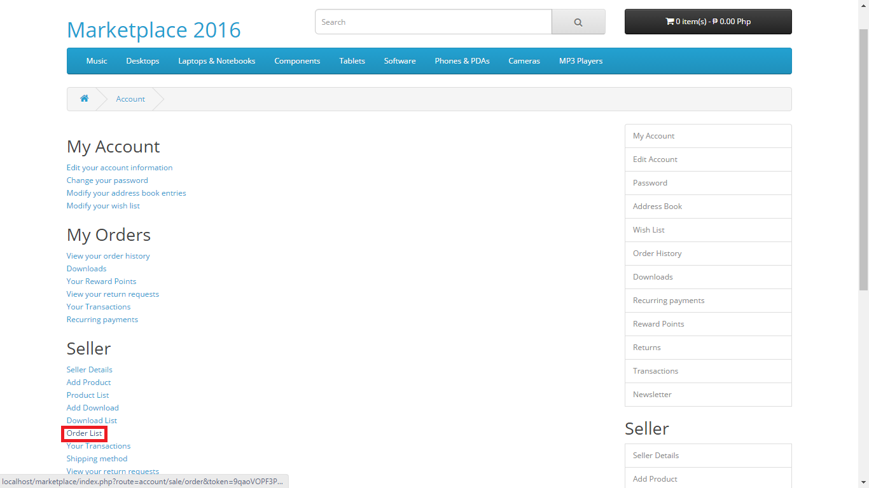**Transaction**

Fig. 6.0. Click “Order List”

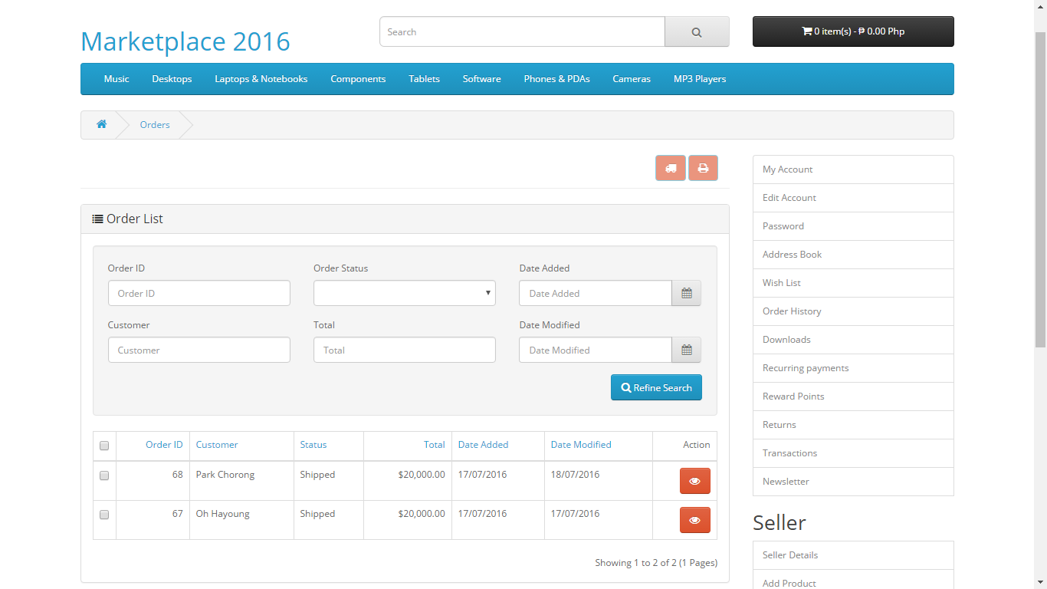

Fig. 6.1. You should be able to view all the list of orders

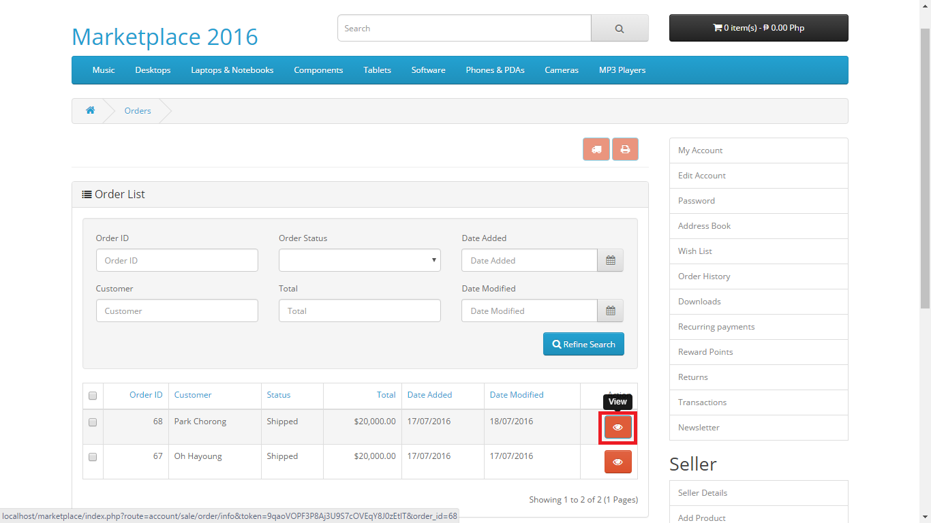

Fig. 6.2. Click “View” to view the information about the specific order

1. **Add/Remove Discount**

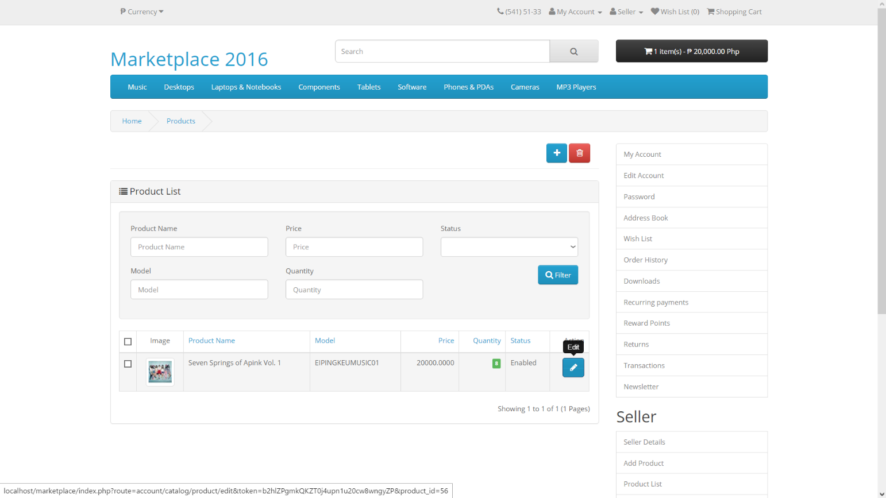

Fig. 7.0. Click “Edit” on the specific product

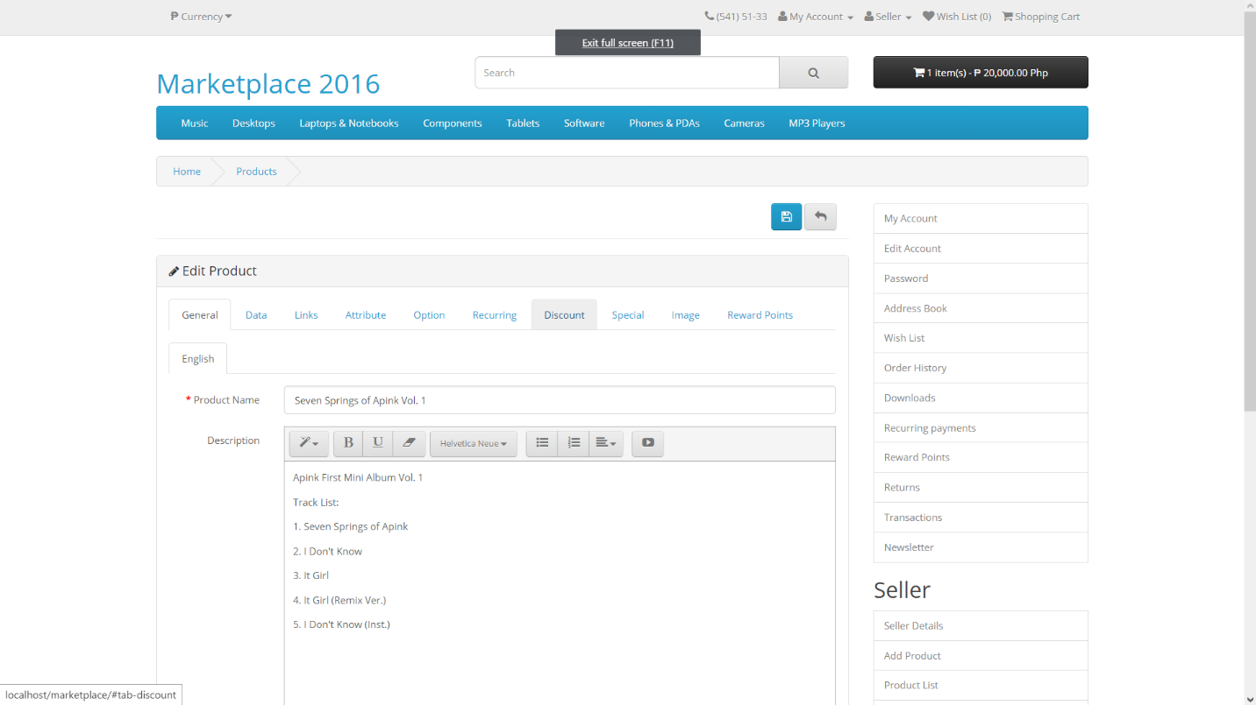

Fig. 7.1. Click the “Discount” tab

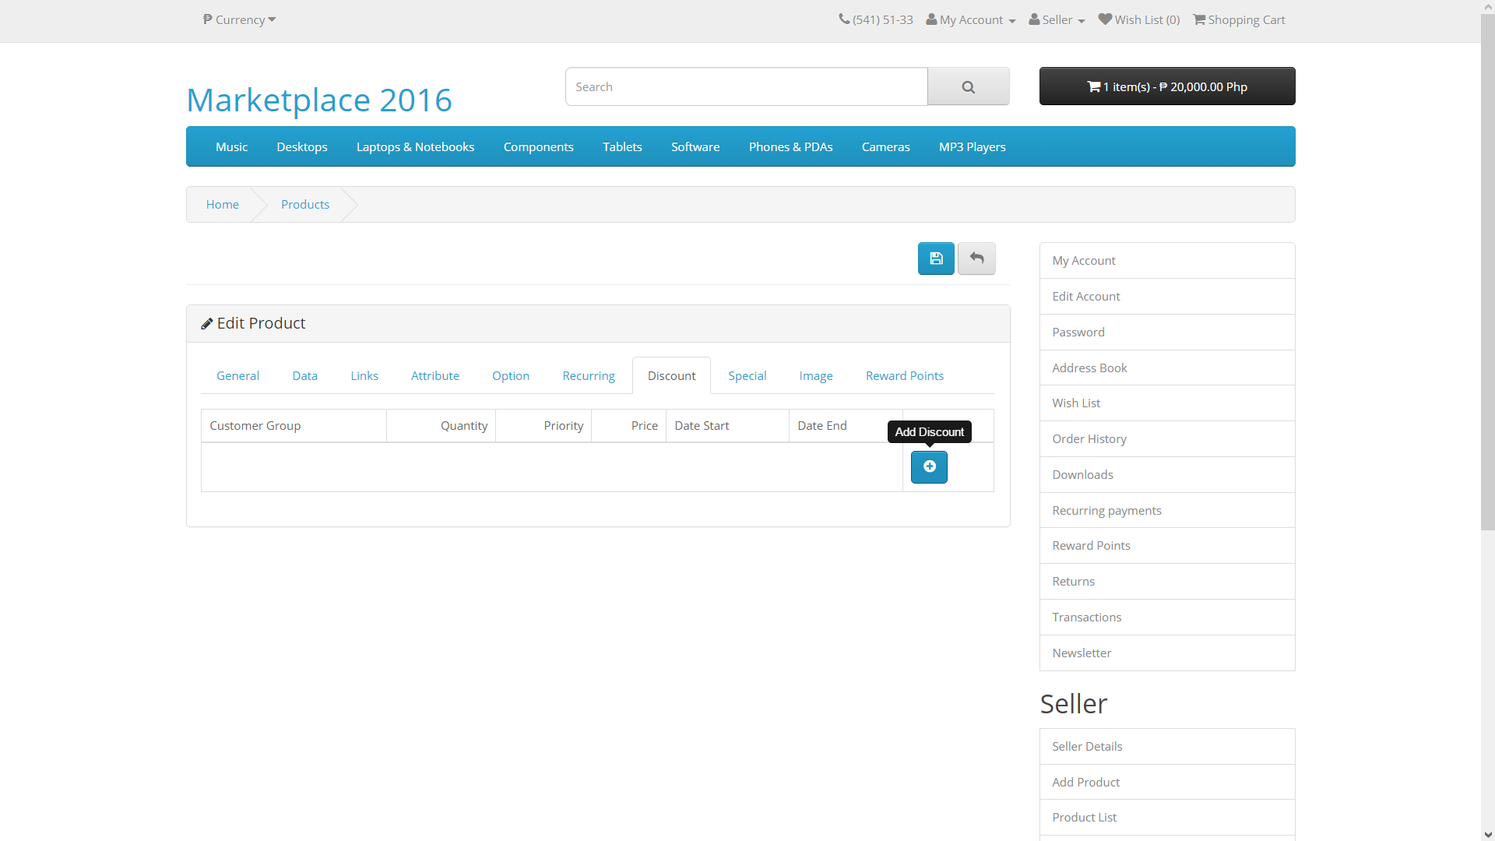

Fig. 7.2. Click “Add Discount”

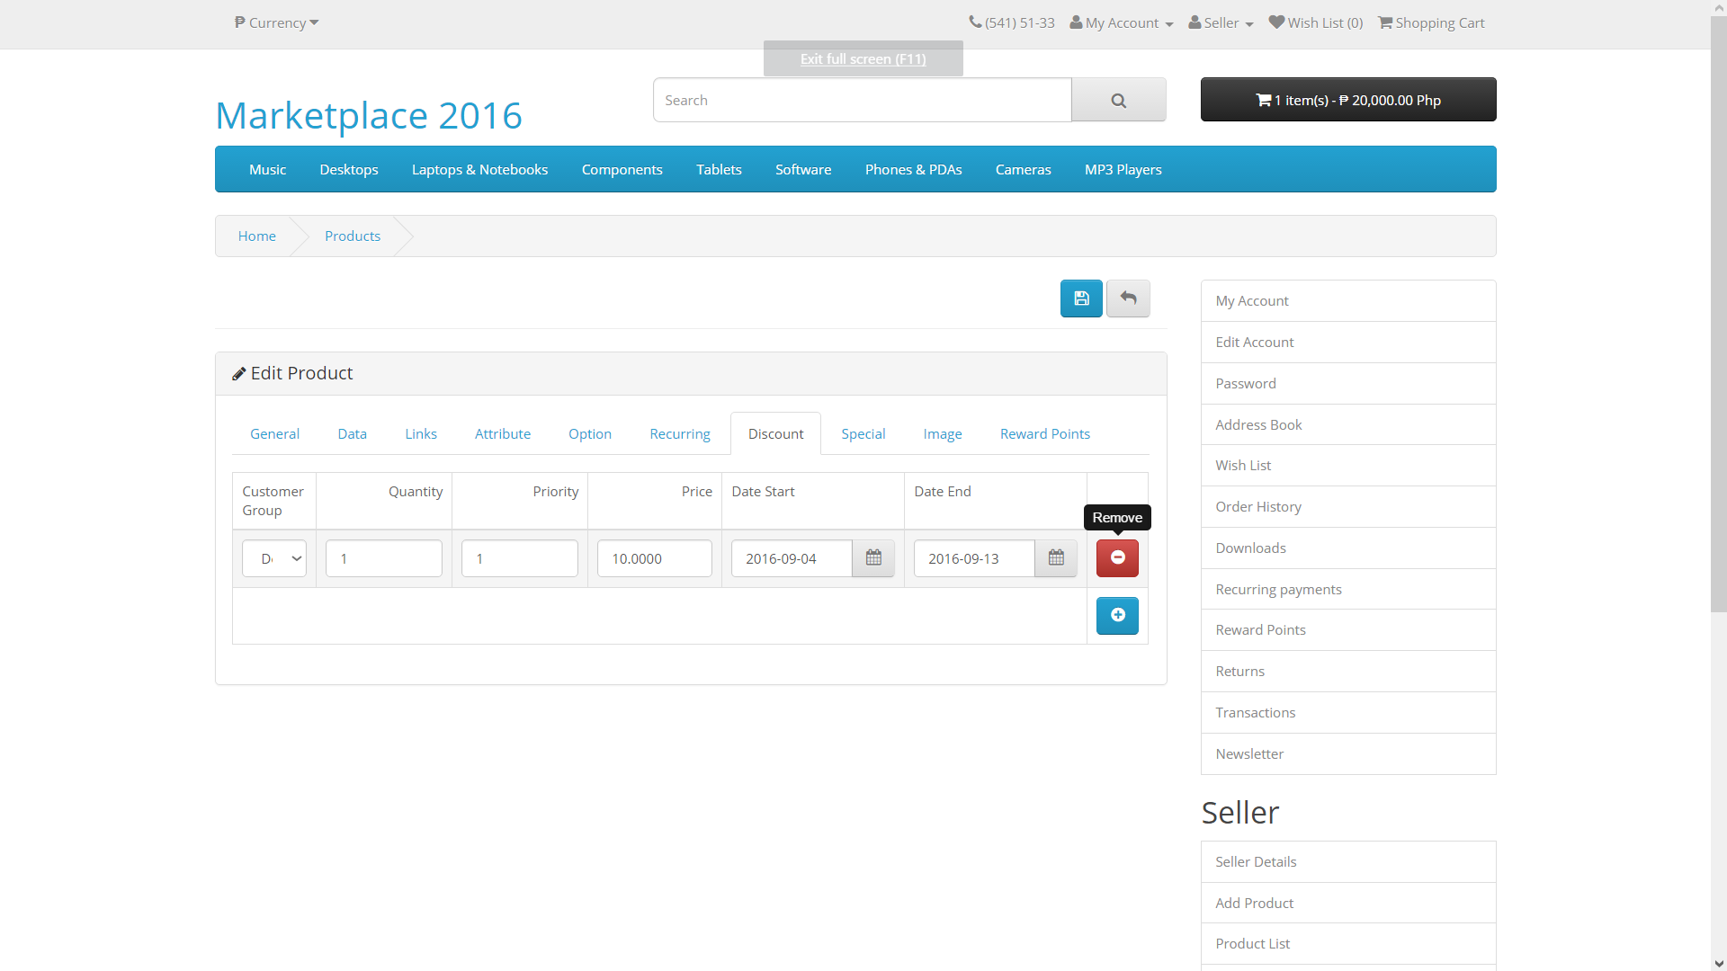

Fig. 7.3. Click “Remove” to remove the discount

# STATION

1. **Manage Merchant**

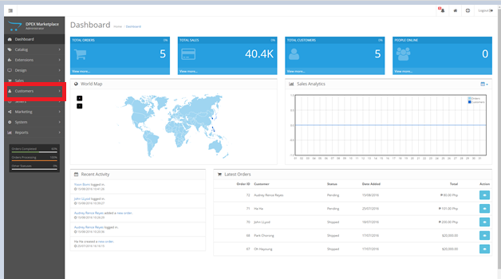Fig. 8.0. Click the customer tab located in the dashboard

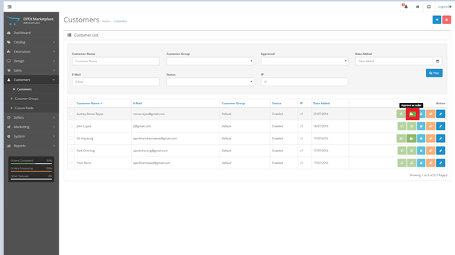

Fig. 8.1. Simply click the approve as seller button in order to make the customer account a seller

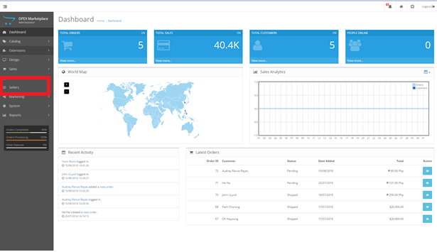Fig. 8.2. To view all merchants, Click the Seller tab in the dashboard to view all the approved merchants

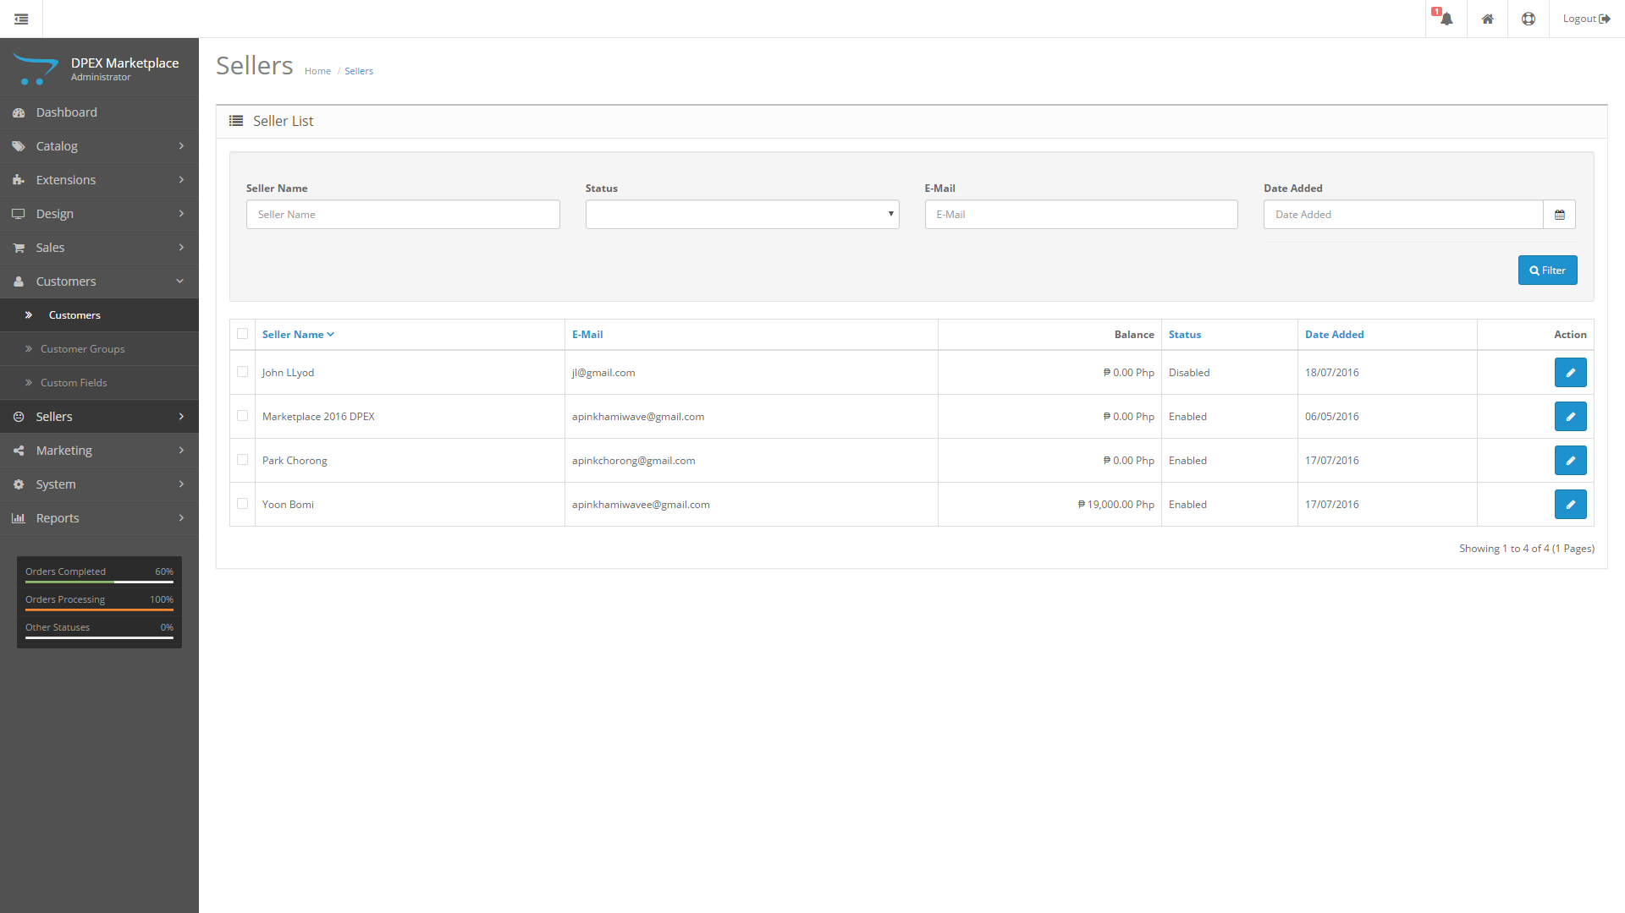

Fig. 8.3. Seller List

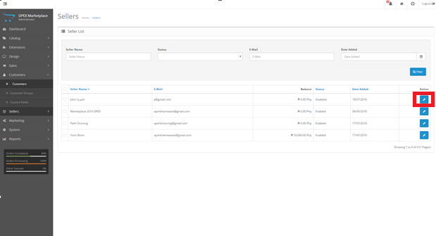Fig. 8.4. From the seller page click the edit button beside the seller you want to suspend located below the action column.

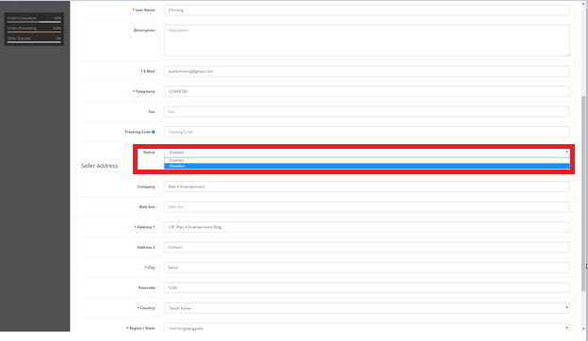

Fig. 8.5. Click the Status tab below the tracking code line and change the enabled to disabled in order to suspend the seller you can also change it back to enabled to reinstate the seller.

1. 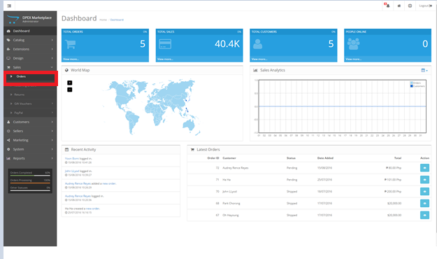**Transaction**

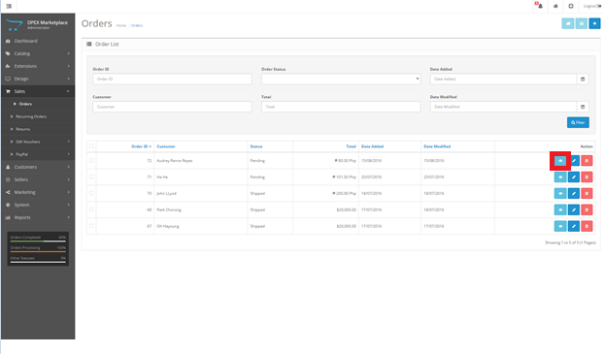Fig. 9.0. Right now you can only view the transaction per customer in order to access it from dashboard click sales then orders.

Fig. 9.1. This will show you all the transactions sorted by costumer click view to see the details of the transaction

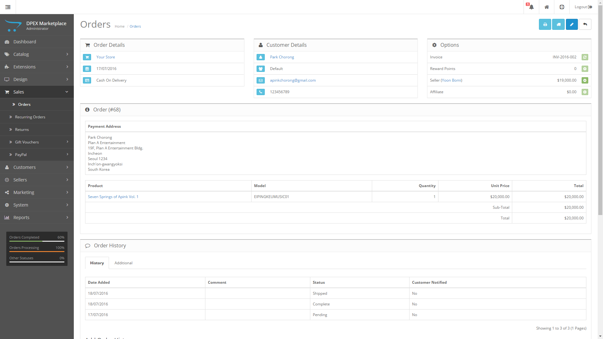

Fig. 9.2 Orders List

1. 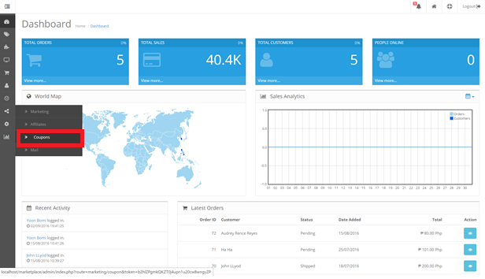**Coupon**

Fig. 10.0. From the Dashboard, select the coupons tab at the side bar

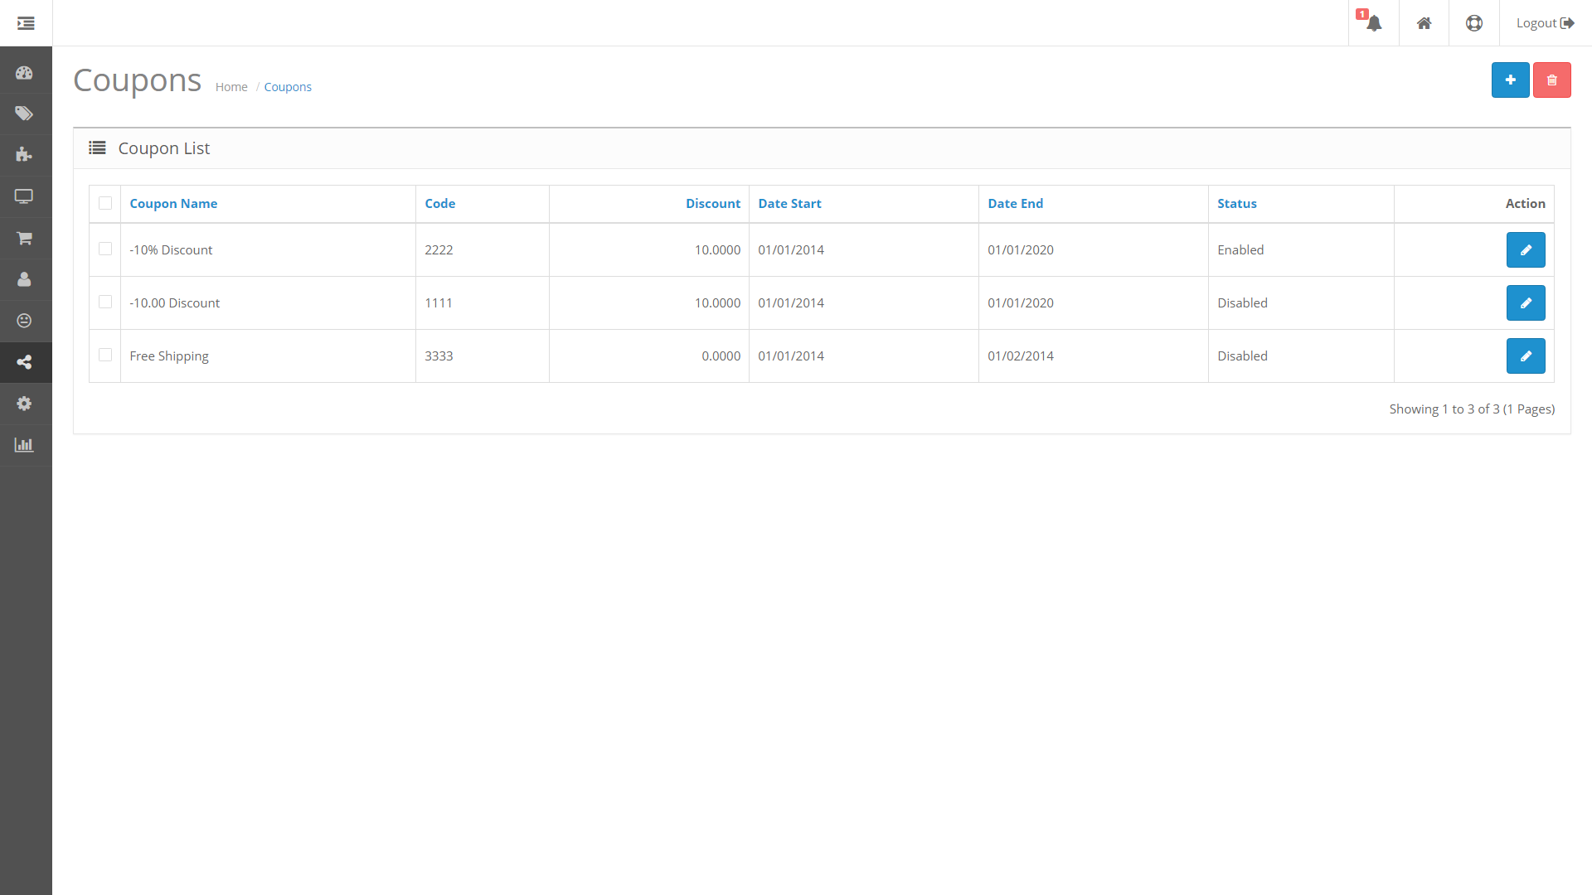

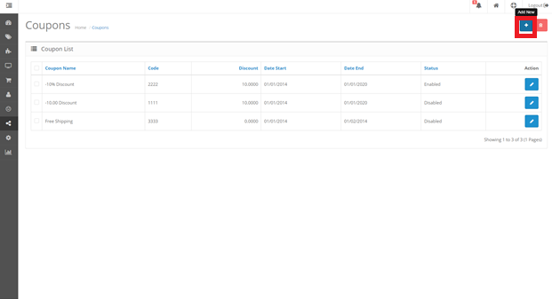Fig. 10.1. Coupons available

Fig. 10.2. To generate coupons, Click the Add new button on the coupon list

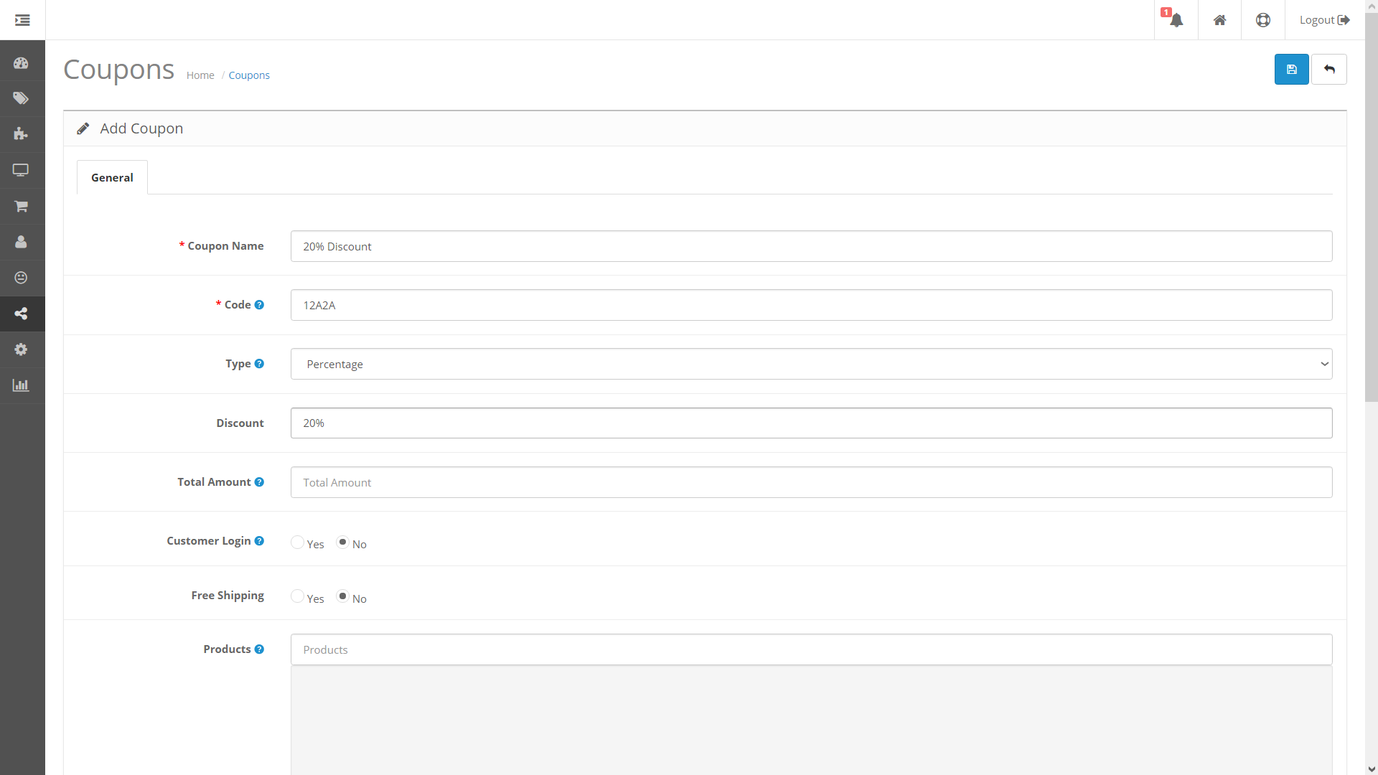

Fig. 10.3. Fill out the fields on the form the * are required fields if no product is typed in the product field the discount will be applied to the entire cart

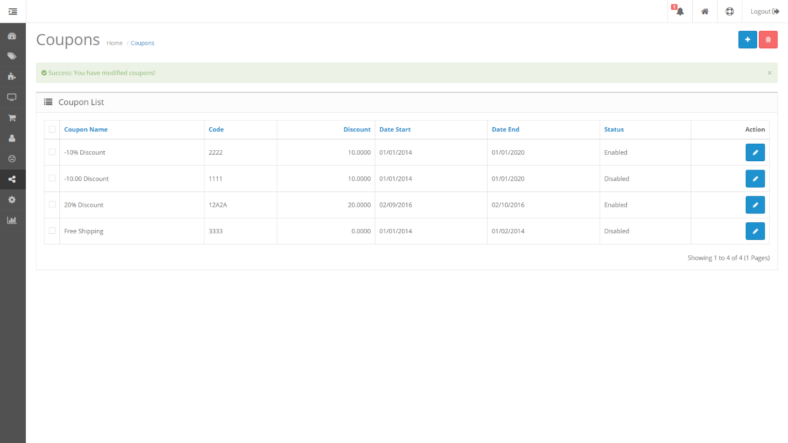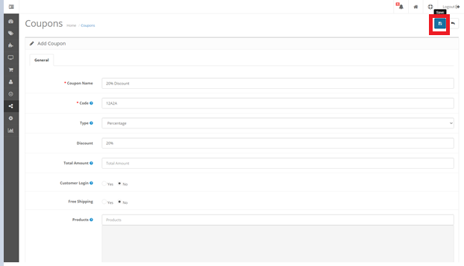Fig. 10.4. Once done click the save button and the new coupon will be added to the coupon list

Fig. 10.0. Coupon List